Mood, atmosphere, and ambience are three interrelated concepts that play pivotal roles in achieving an overall feeling in a space. The goal is to craft environments that evoke emotions and leave lasting impressions. Understanding and effectively applying these elements can transform a space from the mundane to the extraordinary.

Mood refers to the emotional tone or feeling that a space can arouse in its occupants. It can range from calm and serene to lively and energetic. The mood is often the first emotional reaction people experience when entering a room, and it significantly influences their comfort and behaviour.

The atmosphere is the overall character or personality of a space. It encompasses the tangible and intangible aspects that create a unified impression. While mood is an emotional response, atmosphere can be seen as the design framework that shapes this response.

The **ambience** in interior design focuses more on the sensory and experiential qualities of a space. It involves factors such as lighting, sound, scent, and temperature, creating an immersive environment that enhances the user's experience.

In order to achieve all of the above, there are a few things to take into consideration. Let us look at each one individually, and what can influence them:

1. Setting the Mood:

* Consider the **colour** palettes used and the psychological effect they can have.
  + Warm Colours: Red, yellow, and orange create warmth, energy, and excitement.
  + Cool Colours: Blue, green, and purple create calm, relaxation, and serenity.
  + Neutral Colours: Beige, grey, and white provide balance, calmness, and simplicity, often serving as a backdrop for other design elements.

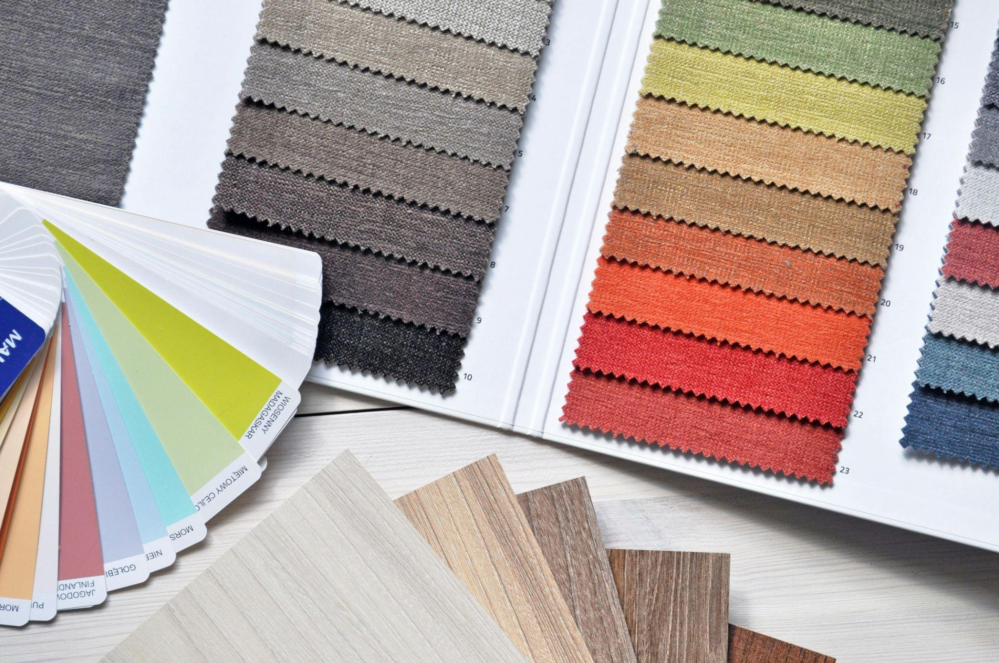

Fig 1. Pexels (n.d.) Colour plays an important role in creating ambience

* Consider **textures** and balance.
  + Soft Textures: Fabrics like linen, velvet, or faux fur create a cozy and warm atmosphere.
  + Smooth, Sleek Textures: Materials like glass, metal, or polished stone evoke a modern, clean, and sometimes cooler atmosphere.
  + Natural Materials: Elements like wood, stone, and plants introduce a sense of calm, grounding the space with a connection to nature.

1. Ambience through sensory elements

* Consider the room's **lighting,** both natural and artificial, and the effect it has on the space.
  + Mood and Ambience: Lighting affects both the mood and functionality of a space. For instance:
    - Natural Light: Enhances energy, productivity, and openness.
    - Artificial Light: Soft or dim lighting creates a cosy and intimate atmosphere, while bright, focused lighting energises and adds clarity.
    - Accent Lighting: Spotlights, pendant lights, and sconces can highlight key areas or objects, adding drama and focus to the ambience.

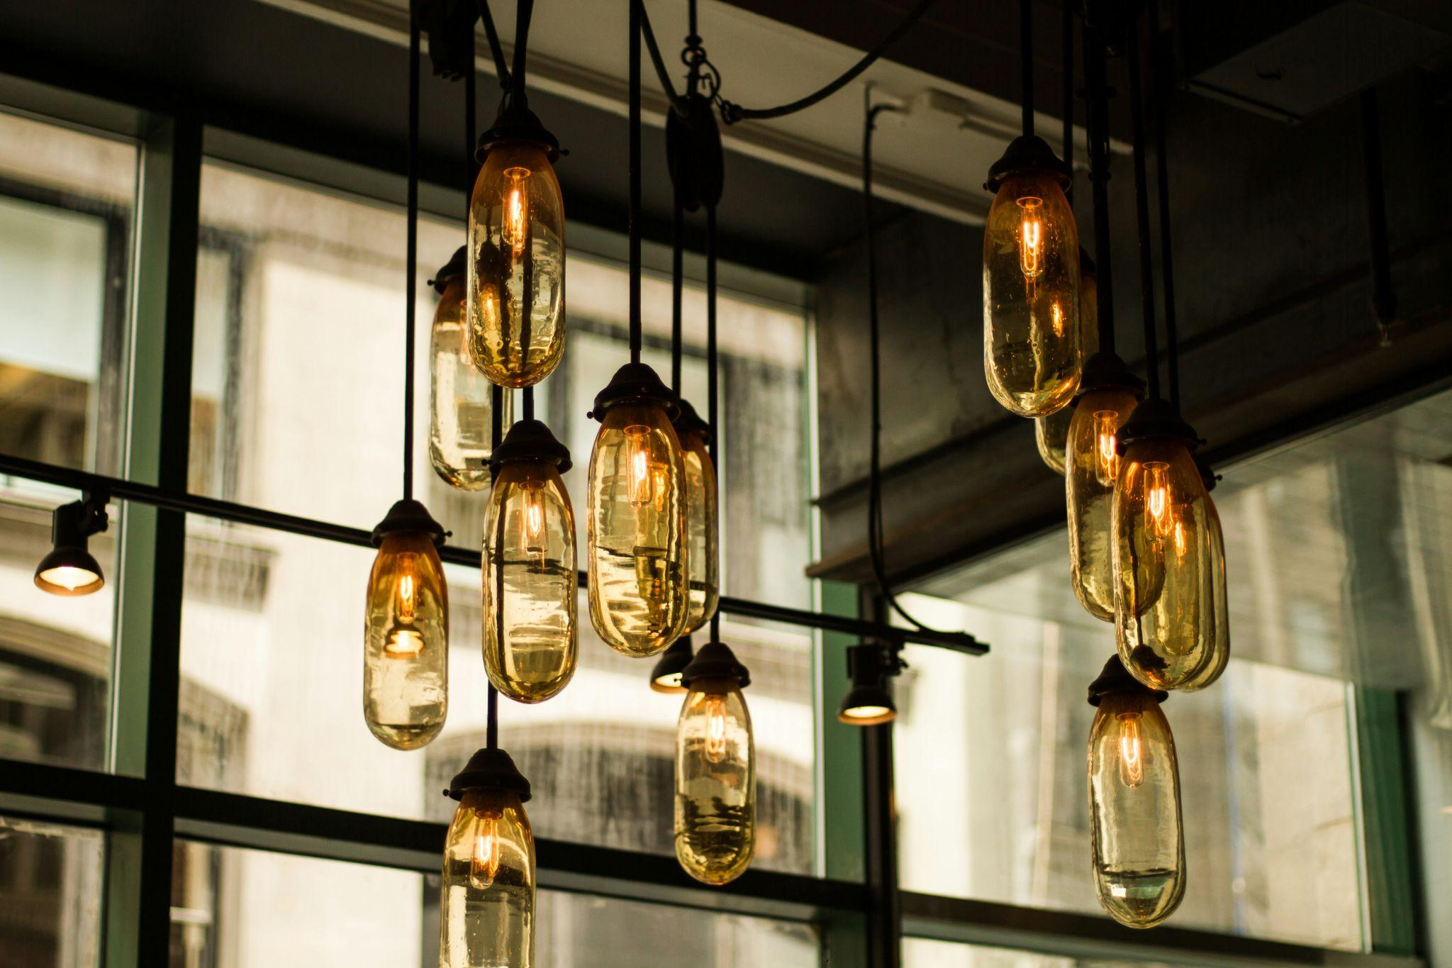

Fig 2. Pexels (n.d.) Lighting plays an important role in creating ambience

* Acoustics and Sound: Soundscaping refers to the deliberate incorporation of sound as a design element to shape the sensory experience of a space. It enhances ambience by influencing mood, creating a sense of comfort, and reducing unwanted distractions.  
  - **Incorporate Natural and Calming Sounds:** Use water features like fountains, ambient nature soundtracks.  
  - **Optimise Acoustic Comfort:** Install sound-absorbing materials such as acoustic panels, rugs, curtains, and upholstered furniture to reduce echo and reverberation, ensuring a quieter and more comfortable environment.  
  - **Mask Unwanted Noise:** Employ white noise machines or sound-masking systems to neutralise disruptive sounds.  
  - **Design for Functional Zones:** Tailor soundscaping to specific areas—play calming sounds in relaxation zones, energising music in active spaces etc.  
  - **Leverage Smart Technology:** Incorporate smart home systems, noise sensors, and automated sound controls to dynamically adjust sound levels, ensuring the ambience aligns with user preferences and activities.
* Scent and Air Quality: These two elements are strongly related to sensory elements and can really affect one's memory of a space.  
  - Scent: Introduce pleasant fragrances through diffusers, candles, or fresh flowers to enhance sensory appeal.  
  - Proper ventilation and air quality also contribute to a fresh and inviting ambience.
* Temperature and Comfort: The physical comfort of a space—determined by temperature, humidity, and ergonomics—significantly impacts how welcoming and enjoyable it feels:  
  - Smart climate control systems can adjust these factors dynamically to enhance the overall experience.

1. Creating atmosphere through Design Principles:

* Unity and Harmony: A cohesive design ensures that all elements work together to create a seamless atmosphere. This includes aligning furniture, decor, and architectural details with the overall theme or style of the project.
* Proportion and Scale: Correct proportions contribute to a harmonious atmosphere. For instance, grand, high ceilings and large windows can create an open and uplifting atmosphere, while low ceilings and intimate nooks foster a cosy and contained feeling.
* Storytelling and Themes: Atmosphere is deeply tied to storytelling. Whether it’s a minimalist retreat or a vibrant bohemian den, having a clear narrative helps guide design decisions and shapes the overall character of the space.

### Style

It is important to remember that mood and ambience are not the same as *style*. A design style follows a set of particular principles, colour harmonies, compositional styles, furniture, etc. It is already fixed and established. For example, you can have Industrial Style, Bohemian, Scandinavian, etc. On the other hand, a mood or ambience is not so much about the principles followed, but rather about how the final outcome speaks to its user and the feelings it creates.

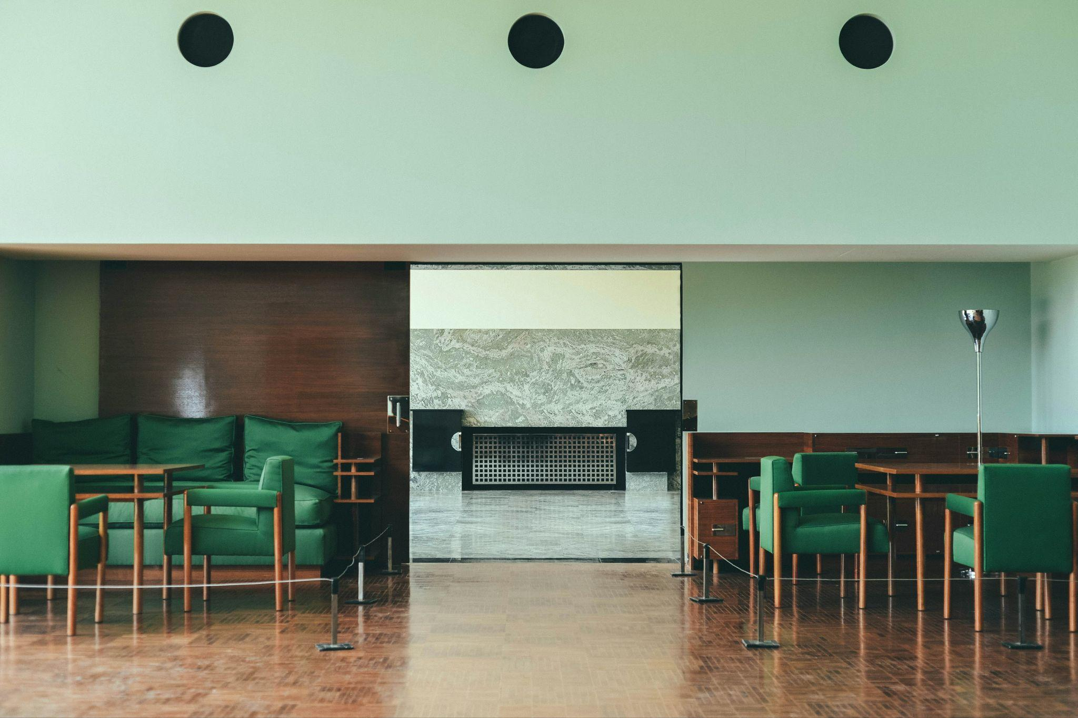

Fig. 2 Unsplash (n.d.) Villa Cavrois by Adam Matthias [Photograph]

Consider the image above. This project, Villa Cavrois, is of a Modernist Style. However, much more can be said regarding the ambience of this room. You can define it as formal and strict, giving the user a sense of a rigorous environment. The colours used, a mix of warm tones of the wood and the colder ones of the marble in the distance, also help create this sense of formality, neither too austere nor too relaxed. The symmetry also provides a sense of balance and equilibrium within the design. Overall, the ambience of this room could be defined as formal, calm and balanced. Nevertheless, as noted before, these definitions of ambience could be subject to personal interpretation, depending on one's experience within the room.

### Final thoughts

Mood, atmosphere, and ambience play a major role in interior design as they define the emotional and sensory experience of a space. By thoughtfully selecting elements such as colour, lighting, textures, and layout, designers can shape how people feel, interact, and function in a room. Whether creating a serene retreat, an energetic workplace, or a cosy living room, mastering these elements helps to create memorable spaces that emotionally resonate.